IAD#_DataSheet.csv

This file contains one row for each of the RefSeq accession numbers of the RNA sequences that are covered by the designed primers. For each row there is extensive information such as the names submitted by the user, the corresponding HGNC approved symbol, the amplicon ID, the sequence of the forward and reverse primers, the start and end coordinates of the primers relative to the RefSeq sequence, the coordinates of the start and end of the amplicon and the start and end of the insert sequence relative to their position in the chromosome and the strand of the chromosome in which the sequence is located. The last two column of this file reports the preferred TaqMan assay that can be used for verification of the particular target and a classification of the of the TaqMan assay with 2 possible values:
- Classification 1: The recommended TaqMan Gene Expression Assay targets the same exon or exon-exon boundary as the Ion RNA AmpliSeq Design.
- Classification 2: The recommended TaqMan Gene Expression Assay targets the same set of RefSeq Accessions as the Ion RNA AmpliSeq Design.

Use the following procedure to get the corresponding TaqMan assay:

- Get the TaqMan ID from the last column of the IAD#_#_DataSheet.csv file and paste it in the “Enter Target Information” box in the Life Technologies TaqMan page and then click the Search button

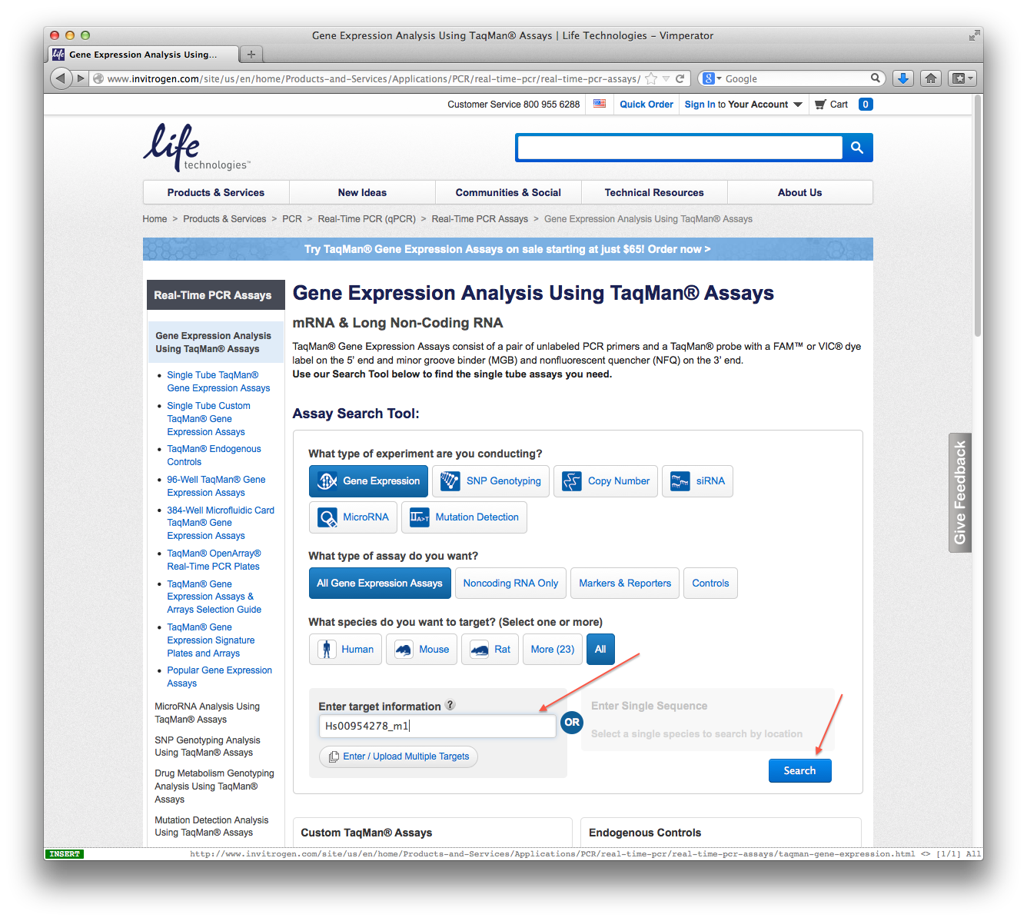
- Information about the equivalent TaqMan assay will be displayed
